One Approach to Dynamical Relocation of Emergency Ambulance Vehicles Based on Geographic Information Systems
Č. Vasić⁺, D. Rančić⁺⁺, B. Predić⁺⁺, D. Mitić⁺⁺
⁺ Dona Farm, Blvd. Dr. Zorana Djindjića 40a, 18000 Niš, Serbia
Phone: +381 (18) 230-374, Fax: +381 (18) 202-092, E-Mail: info@dona.rs
⁺⁺ University of Niš, Faculty of Electronic Engineering, A. Medvedeva 14, 18000 Niš, Serbia
Phone: + 381 (18) 529-105, Fax: +381 (18) 588-399, E-Mail: {dejan.rancic, bratislav.predic, darko.mitic}@elfak.ni.ac.rs

Abstract— In this paper, information on ambulance vehicles routes, extracted from the Geographic Information System (GIS) database, are used in calculations of optimal vehicles location coordinates during their waiting for call time period. The mathematical problem known as p-median is utilized and resolved by the appropriate algorithm implemented in three steps. The given optimisation method is tested on site.
Keywords— GIS, Emergency Ambulance Service, relocation, p-median
I. Introduction
The location-allocation problems of resources have been treated in different scientific fields many times in the last century. The researchers keep in focus of interest the problems of planing services in public sector. The emergency medical help and ambulance services are specially targeted fields, according to the human nature of the service users. The fundamental break through is accomplished by developing spatial model based on Geographical Information System (GIS) and by modern computer technology. The vehicle tracking units, utilized Global Positioning System (GPS), and the appropriate GIS software allow dynamical analysing and optimal decision making process, concerning the location-allocation problem of different purpose vehicles.
Several questions arise when someone considers the planing of emergency sector services: how many vehicles has to be purchased and be available in any moment, where to build garages, how to provide mechanisms of decision making and answer offering, which vehicle to be used (allocated) and where to locate the parking place for vehicle in waiting for next call status (vehicle relocation).
We assume that we have no influence on the technical level of equipment used in emergency services and, consequently, this problem is out of scope of our paper. Therefore, the quality improvement of the services is only possible by better personal training or shorter ambulance vehicle response time. Since all vehicles parked in one central garage is not good solution for reducing the response time, we use history of ambulance vehicle routes in recent period (last 30 days) and the spatial locations (potential vehicle relocation points) of the served calls to perform data analysis and to recalculate the optimal vehicle location at any time. Although the goal to find the most quickest route to destination suffers from many complex impacts, the main influence has the Euclidian distance. Traffic jams, rush hours, road reconstruction, weather conditions, time of the year and other conditions are not taken into consideration and need to be involved in dynamical allocation modelling in the future work. In order to solve this relocation problem, we use the p-median problem approach.
The paper is organized as follows. In section II, p-median problem is introduced. The previous works, treating this mathematical problem, are surveyed in section III. The problem of ambulance vehicle relocation, consider in this paper, is formulated in section IV. In section V, the implemented algorithm is presented both with the real-time results obtained from the experimental framework.
II. P-median Problem
The problem how to locate p-facilities (called medians), so as to minimize the sum of the distances from each demand point to its nearest facility, is clearly defined in early sixties of last century as a p-median problem. The resolving of this problem is classified as Non-deterministic Polynomial-time (NP) hard problem. For even moderate values of demand points n and facilities p, the number of possible solutions can be very large and it is defined by:
$\left(\begin{matrix}n \\ p\end{matrix}\right)=\frac{n!}{p!(n−p)!}$. (1)
For instance, if n=1000 and p=10, the total amount of possible solutions is 2.63.10²³. In this paper, p-median problem is modelled as the binary integer programming problem, explained as follows. Find minimum of:
$\sum_{i∈I}{\sum_{j∈J}{ω_{j}d_{\text{ij}}y_{\text{ij}}}}$ (2)
subject to constraints:
$\sum_{i∈I}{x_{i}=p}$ (3)
$\sum_{i∈I}{y_{\text{ij}}}=1, ∀j∉J$ (4)
$y_{\text{ij}}−x_{i}≤0, ∀i∈I,j∈J$ (5)
$x_{i}∈\left\{0,1\right\}, ∀i∈I$ (6)
$y_{\text{ij}}∈\left\{0,1\right\}, ∀i∈I,j∈J$ (7)
where $ω_{j}$ is weighting factor of location j, d_{ij} is an Euclidian distance between i location for vehicle parking and j demand for service. The constraint (3) defines that p is a total number of vehicles which we need to relocate, (4) tells that one demand can be served only by one vehicle, (5) suppress possibility to serve demand from location without a vehicle, (6) shows that on one parking place can be only one whole vehicle (vehicle can not be divided on several locations) and in the end (7) ensures that one demand can be serviced with only one vehicle (not with two halves of two different vehicles). Some of the constraints can be removed or avoided and that is the relaxation of problem. Some additional constraints can be introduced. For example, it is possible to define a maximum value for d_{ij}, establishing a maximum allowed call response time in that way, or to determine a maximum allowed number of calls serviced by one vehicle (the capacity constraints).
III.Previous works
P-median problem is originally defined in the work of Hakimi [1], where the continuous space surface is divided into discrete network and it is assumed that medians can be placed only in the graph vertices. There is at least one optimum solution of the problem [2]. Hakimi proposed simple enumeration procedure named direct enumeration for calculation of one or more medians. ReVelle and Swain [3] provided the linear programming formulation of problem and involved integer variables in numeric resolving. Their work is considered as the fundament for all later proposed methods.
As an alternative to direct enumeration approach, heuristic methods are developed as two phase algorithms. First phase is always dedicated to efforts to find starting set of p-medians, and the second phase is made from iterations, dedicated for solution improving. The final solution is very close to the optimal one, or sometimes it represents the optimal solution. There are three primary heuristic methods: greedy [4], alternate [5] and vertex substitution [6], [24], [25], [26].
When it is impossible to find starting set of medians by direct enumeration, the methods known as Lagrange relaxation are introduced and iterations are implemented in several different ways: by sub gradient-relaxation or growing-optimisation, brunch and bound, double-incrementing or surrogate optimisation. The milestone work is the algorithm of Narula, Ogibu and Samuelsson [22]. Some of most successful methods based on Lagrange relaxation are proposed by Cornuejols, Fisher and Nemhauser [19], Hribar and Daskin [20], Khumawale [21]. The newest, surrogate relaxation from Senne and Lorane [23] use new approach to find range of multiplier values that improve the bounds of the usual relaxation technique. It is possible to generate approximate solutions at least as good as traditional relaxation technique while reducing computational effort for larger problems.
There are also many papers explaining metaheuristic and approximation algorithms such as: variable neighbourhood search [7-9], greedy randomized adaptive search procedure [10], genetic algorithms [13-15], tabu search [12], [16], heuristic concentration [11], simulated annealing [17], [18] and neural networks.
The implementation of the model, based on input data obtained from GIS, combined with algorithm resolving p-median problem in optimization problem of Emergency Medical Service is the often issue in the literature, although the problem definition and the interpretation of results differ from the case to case. The extensive studies dedicated to the optimization of Emergency Service in many cities are available [28-30]. Different system parameters, sources and data structures, as well as different process goals powered by everyday technology improvement, make these subject very interesting for further research.
IV. Problem Formulation
Emergency Medical Service in city of Niš, Serbia, is the public service organized to meet needs of not only the residents of the downtown, but also the residents of 68 neighborhood settlements. There are more than 300.000 habitants on 600 km² territory and in order to succeed their needs, the service use 24 ambulance vehicles and dozen vehicles with specific and unique medical equipment. The fleet is relatively new, well equipped with up-to-date standard ambulance medical and other units, including the units for the satellite tracking and navigation. Four vehicles are always ready to intervene with complete stuff, covering 8 hours long shift. These teams are available to the dispatcher in the call-center who accepts requests for services and makes decision who and when will response to the call. If there is no requests for service, the vehicles are in the central garage In addition to 4 vehicles on duty, there are 5 vehicles ready to be used in some unpredictable extraordinary situation.
In this paper, we assume that the ambulance vehicle do not need to wait for call in the central garage, but it should be parked on the location determined to minimize the average response time. Each used vehicle gets coordinates of its waiting for call location and after finishing the service goes directly to that location. The city map is divided into 4 regions and one region is matched with one vehicle. The waiting for call locations can be obtained in two different ways. One way is to model the complete process and to use this model to predict the best location of vehicle. The quality of solution depends on the developed model accuracy. The another way is to analyze the recent time period and to find locations as the best solution for already accomplished services. If the proposed location represent optimal solution for past 30 days, the assumption is that it will be the optimal solution for the next day as well. Therefore, the optimal solution is found based on the real vehicle exploitation data and not on the basis of the expected, hypothetic vehicle use in the future.
V. proposed algorithm Description
In order to solve the given problem, three phase algorithm is created. In the first phase, the coordinates of interest are extracted from GIS database. In the second phase, the starting set of medians is calculated by using the adjusted Teitz and Bart procedure [6]. The starting set of medians is improved in the third phase by heuristic method through several iterations. It is obvious that in 30 days period, one ambulance vehicle can response only to couple of hundred calls, and the complete emergency medical center fleet can execute one or two thousand interventions. The number of engaged vehicles p is also restricted. If number of interventions arises to one hundred thousand or more, the proposed model is no more suitable and it is recommended to implement another type of algorithm, for example some metaheuristic or approximate method.
In the first phase of algorithm, all necessary information is extracted from GIS database, including the determination of n locations of services both with weighting factors. Then, in the second phase of algorithm, starting with the basic assumption that any node in pool of n-demand nodes is qualified to be median, we construct nxn matrix of distances with weighting factor. The matrix element d_{ij} denotes the distance from demand node i to the waiting for call vehicle location j multiplied by weighting factor of the node j. Initially, we want to find the best parking location for one vehicle. For that purpose, the procedure named 1-median is applied. The third matrix column is the array of distances from the parking place located in the node number “3” to all other demand nodes. The sum of all elements in this third column represents the total distance vehicle has to travel to serve all demand nodes, starting each time from the location in the node number “3”. This sum, named cost function of location “3”, becomes the measure of location “3” quality and it is used to compare this location with the others. In our case, we use distances in calculations, but the procedure is the same both in the cases when we use time or fuel consumption necessary to travel from one point to the another.
Suppose that after the calculations of all location costs, the minimum cost function corresponds to the location “3”, meaning that if we have just one vehicle, it has to be parked in the location “3”. It is the first median of our matrix. The cost of node number “3” will not remain unchanged through future calculations, since it is influenced by other medians.
In order to find the next location for another vehicle the third row is filled with zeroes (zero kilometers), because if the call demand comes from the location node “3”, it is not served since the vehicle is already there. The 1-median procedure is applied again on the transformed matrix and we get the second median. The whole cycle is repeated for every next vehicle, p-times. The algorithm of the second phase is represented in Fig. 1. Since that every location change cost functions of locations, it is obvious that the optimal solution is far from the starting set of medians. The sum of all cost functions of locations for all medians in the first set is a total cost function of solution and quality measure for further evaluations.
In the third phase of algorithm, all remaining nodes (n-p), are divided into p subsets, according to the criteria which of the starting p medians is nearest. In that way we realize some kind of the process named neighborhooding. As we have already calculated the total cost function of the starting solution, we start with improvement of algorithm. For each demand node we have vehicle parking location in its neighborhood. In our example we have 4 subsets of neighborhooded nodes. We apply the 1-median procedure on each of these subsets and find the local minimum. If the calculation justifies that the local minimum is the same as the previously selected median we continue with the next subset. If the calculation finds that the local minimum has smaller total cost function than previously chosen median the vertex substitution is done and this local minimum is now new part of the final solution. We perform new neighborhooding then and calculate the total cost of new solution. The whole process is repeated until there is no local minimum with smaller cost function than the cost function of selected median and no nodes change its subset. The third phase of algorithm is represented in Fig. 4.

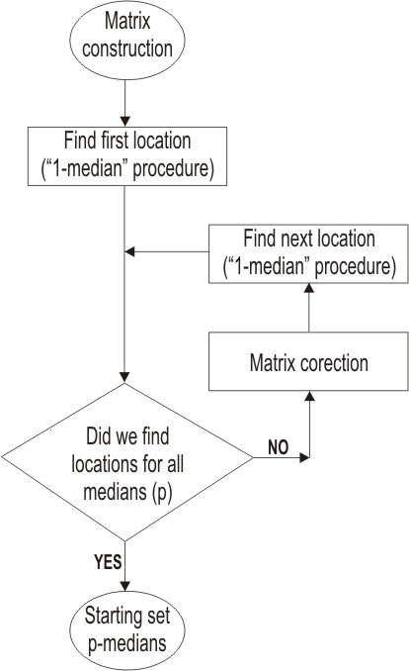

Fig. 1 The second phase algorithm

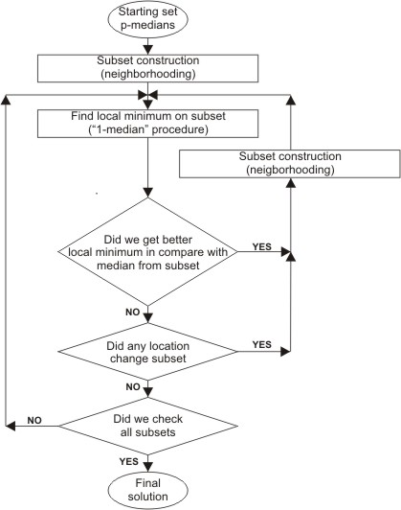

Fig. 2 The third phase algorithm

The optimal solution is finally reached and the set of parking locations for relocation of vehicles is obtained and, consequently, the subsets of demand nodes is formed. According to the spatial position of demand nodes the whole region can be splited into p-sub regions with suitable color representation in GIS, helping dispatcher in decision making process of proper vehicle relocation. In Fig. 3 the history of one vehicle routes in 30 days period is shown, representing the input data for our algorithm. The final location of medians (4 vehicles) is presented in Fig. 4.

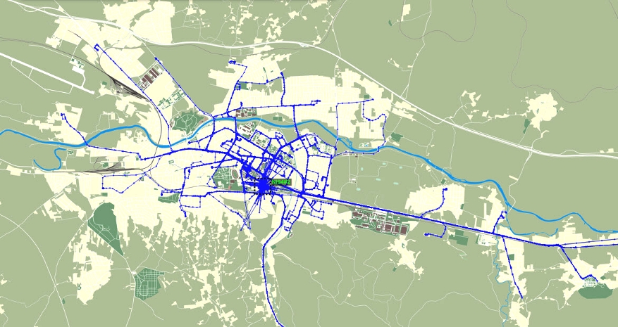

Fig. 3 Emergency ambulance vehicle route history
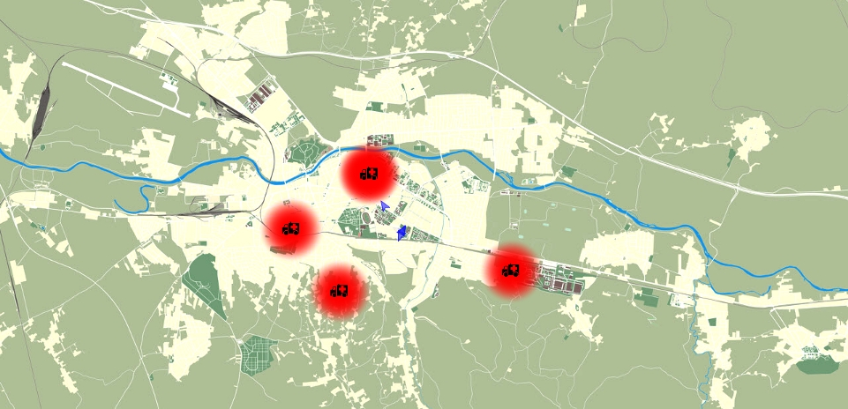

Fig. 4 The final waiting for call vehicle locations
VI. Conclusion
The practical results show that the modified Teitz and Bart method [6] represents the suitable tool for resolving p-median problem in the networks with approximately thousand nodes and dozen medians such as emergency ambulance vehicle relocation. It is verified that the vehicle average response time is smaller if it waits for call on the proposed parking locations. Our solution is proposed to become a standard routine in Emergency Medical Service in city of Niš. The further research efforts should incorporate an extra set of data related to GIS in our algorithm, necessary for vehicle route planning and navigation to desired destinations.
References
- S. L. Hakimi, “Optimum locations of switching centers and the absolute centers and mediansof a graph”, Operations Research, Vol. 12(3), pp.450–459, 1964.
- S. L. Hakimi, “Optimum distribution of switching centers in a communication network andsome related graph theoretic problems”, Operations Research, Vol. 13(3), pp.462–475, 1965.
- C. ReVelle, R. Swain, “Central facilities location”, Geographical Analysis, Vol. 2, pp. 30–42, 1970.
- A. A. Kuehn, M. J. Hamburger, “A heuristic program for locating warehouses”, Management Science, Vol. 9(4), pp.643–666, 1963.
- F. E. Maranzana, “On the location of supply points to minimize transport costs”, Operations Research Quarterly, Vol. 15(3), pp.261–270, 1964.
- M. B. Teitz, P. Bart, “Heuristic methods for estimating the generalized vertex median of aweighted graph”, Operations Research, Vol. 16(5), pp. 955–961, 1968.
- P. Hansen, N. Mladenovic, “Variable neighborhood search for the p-median”, Location Science, Vol. 5(4), pp.207–226, 1997.
- F. Garcıa-Lopez, B. Meli´an-Batista, J. A. Moreno-Perez, J. M. Moreno-Vega, “The parallel variable neighborhood search for the p-median problem”, Journal of Heuristics, Vol. 8(3), pp. 375–388, 2002.
- T. G. Crainic, M. Gendreau, P. Hansen, N. Mladenovic, “Cooperative parallel variable neighborhood search for the p-median”, Journal of Heuristics, Vol. 10(3), pp. 293–314, 2004.
- M. G. C. Resende, R. F. Werneck, “A hybrid heuristic for the p-median problem”, Journal of Heuristics, Vol. 10(1), pp. 59–88, 2004.
- K. E. Rosing, C. S. ReVelle, “Heuristic concentration: Two stage solution construction”, European Journal of Operational Research, Vol. 97(1), pp. 75–86, 1997.
- E. Rolland, D. A. Schilling, J. R. Current, “An efficient tabu search procedure for the p-median problem”, European Journal of Operational Research, Vol. 96(2), pp. 329–342, 1996.
- O. Alp, E. Erkut, Z. Drezner, “An efficient genetic algorithm for the p-median problem”, Annals of Operations Research, Vol. 122, pp. 21–42, 2003.
- L. A. N. Lorena, J. C. Furtado, “Constructive genetic algorithm for clustering problems”, Evolutionary Computation, Vol. 9(3), pp. 309–328, 2001.
- C. M. Hosage, M. F. Goodchild, “Discrete space location-allocation solutions from genetic algorithms”, Annals of Operations Research, Vol. 6, pp. 35–46, 1986.
- S. Salhi, “Defining tabu list size and aspiration criterion within tabu search methods”, Computers and Operations Research, Vol. 29(1), pp. 67–86, 2002.
- G. Righini, “A double annealing algorithm for discrete location/allocation problems”, European Journal of Operational Research, Vol. 86(3), pp. 452–468, 1995.
- F. Chiyoshi, R. D. Galvao, “A statistical analysis of simulated annealing applied to the p-median problem”, Annals of Operations Research, Vol. 96, pp. 61–74, 2000.
- G. Cornuejols, M. L. Fisher, G. L. Nemhauser, “Location of bank accounts to optimize float: an analytical study of exact and approximate algorithms”, Management Science, Vol. 23, pp. 789–810, 1977.
- M. Hribar, M. S. Daskin, “A dynamic programming heuristic for the p-median problem” European Journal of Operational Research, Vol. 101(3), pp. 499–508, 1997.
- M. B. Khumawala, “An efficient branch-and-bound algorithm for the warehouse location problem”, Management Science, Vol. 18(12), pp. :718–731, 1972.
- S. C. Narula, U. I. Ogbu, H. M. Samuelsson, “An algorithm for the p-median problem”, Operations Research, Vol. 16(5), pp. 955–961, 1968.
- E. L. F. Senne, L. A. N. Lorena, “Lagrangean/surrogate heuristics for p-median problems”, In M. Laguna, J. Gonzalez-Velarde, editors, Computing Tools for Modeling, Optimization and Simulation: Interfaces in Computer Science and Operations Research, pp. 115–130. Kluwer Academic Publishers, 2000.
- P. J. Densham, G. Rushton, “Designing and implementing strategies for solving large location-allocation problems with heuristic methods”, Technical Report 91-10, National Center for Geographic Information and Analysis, Buffalo, NY, 1991.
- R. A. Whitaker, “A fast algorithm for the greedy interchange of large-scale clustering andmedian location problems”, INFOR, Vol. 21(2), pp. 95–108, 1983.
- M. G. C. Resende, R. F. Werneck, “On the implementation of a swap-based local search procedure for the p-median problem”, In R. Ladner, editor, ALENEX ’03: Proceedings of the Fifth Workshop on Algorithm Engineering and Experiments, pp. 119–127, Philadelphia, SIAM, 2003.
- T. H. Schietzelt, P. J. Densham, Spatial Modelling, Chapter 17 Location-allocation in GIS, Cadcorp Ltd., Stevenage, United Kingdom, 2001.
- C. K. Lindeskov, Ambulance Allocation Using GIS, Master Thesis. Technical University of Denmark. August 2002.
- I. Pasha, Ambulance Management System Using GIS, Master Thesis in Geoinformatics. Linkoping University. Sweden. May 2006
- N. M. Ruslim, N. A. Ghani, An Application of the p-Median Problem with Uncertainty in Demand in Emergency Medical Services. University Sains Malaysia, Penang. June 2006

